ORAL PRESENTATION: My Favorite Place

- Choose a place.
- Write 8 sentences using There is, There are, There isn’t, There aren’t.
- Click on two icon and talk about what you can do there.
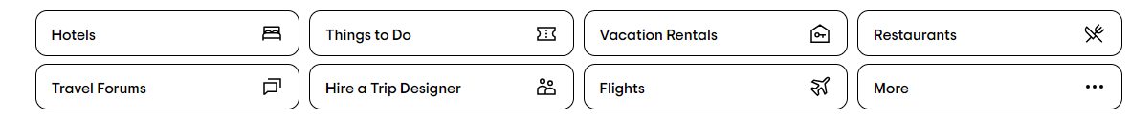

- Do a PowerPoint presentation or Canvas Presentation.

References

Mendelsohn, H., & Saint-Elien, M. (2023, December 13). The 62 most beautiful places in the world to visit. House Beautiful. https://www.housebeautiful.com/lifestyle/g4500/most-beautiful-places-world/

