MY CHILDHOOD MEMORIES.
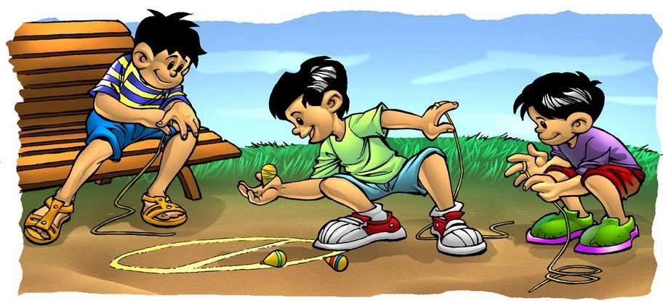
Hello. My name is Keny. I am going to talk to you about my childhood memories. When I was a child, I played with my barbies with my sisters and my cousins. I made clothes for my dolls in my mom’s sewing machine. I also played hide-and-seek and jumped rope with my cousins and my aunts in the neighborhood every night. We were very noisy, and my mother and grandparents got really angry because they didn’t listen to their favorite soap opera on TV. I usually watched music programs on TV, but I also watched The Transformers, The Thundercats, and Tom and Jerry. I used to play “trompo, las ollitas, esconde la faja, and las cebollitas” with my siblings and cousins. On vacations we went to the beach with my parents but I didn’t swim because I was sick. I was a really happy child and my childhood was really beautiful.
EXERCISE 1.
Answer the following questions about the text.
- What did she play when she was a child?
- What did she do for her dolls?
- Did she watch music programs on TV?
- Who did she play different games with?
- Where did she go on vacations?

EXERCISE 2.
Find six VERBS IN SIMPLE PAST in the text.
- __________________________________ 4. _________________________________
- __________________________________ 5. _________________________________
- __________________________________ 6. _________________________________
EXERCISE 3
Complete the sentences that are POSITIVE.
- She _____________________________with barbies when she ____________a child.
- She _____________________________The Transformers, and The Thundercats on TV.
- She _____________________________to the beach.
Complete the sentences that are NEGATIVE.
- She ____________________________at the beach because she __________sick.
- She ____________________________soap operas on TV.
- Her parents ____________________________to their favorite soap opera.
EXERCISE 4.
Circle all the sentences in SIMPLE PAST in the text.
EXERCISE 5.
Now Use the verbs to create sentences that are true for you. Use the SIMPLE PAST.
- Travel (+)__________________________________________________________________
- Eat(+)_____________________________________________________________________
- Drink(+) __________________________________________________________________
- Visit (-)____________________________________________________________________
- Play (-)____________________________________________________________________
- See(-)_____________________________________________________________________

EXERCISE 7.
Now write things DID on your last vacation.
- __________________________________________________________________________
- __________________________________________________________________________
- __________________________________________________________________________
- __________________________________________________________________________

