MOVIE GENRES CROSSWORD.
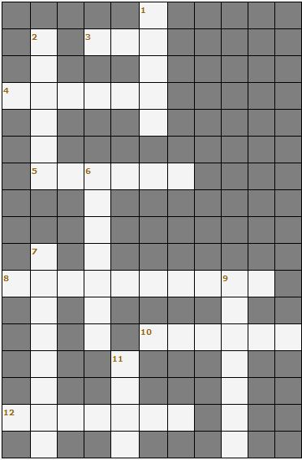
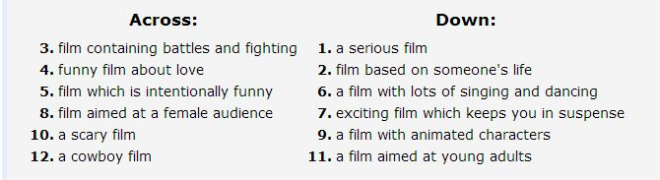

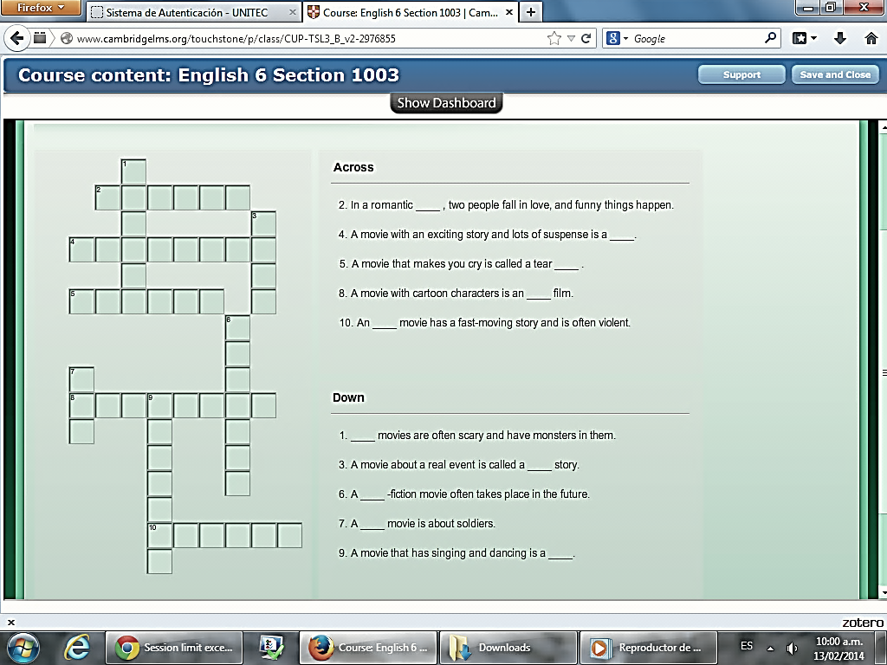

Complete the sentences with your options.

- Best movie ever? _________________________
- Worst movie? ____________________________
- Best actor? ______________________________
- Worst actor? ____________________________
- Best actress? _____________________________
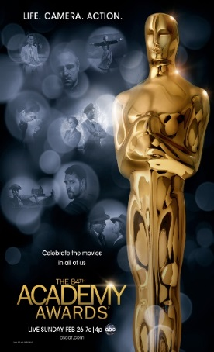
- Worst actress? ____________________________

