MODAL VERBS SPECULATION – DEDUCTION
PRESENT / PAST
NAME:___________________________________________ DATE:_____________________
- Select the correct word from parenthesis to complete each sentence.
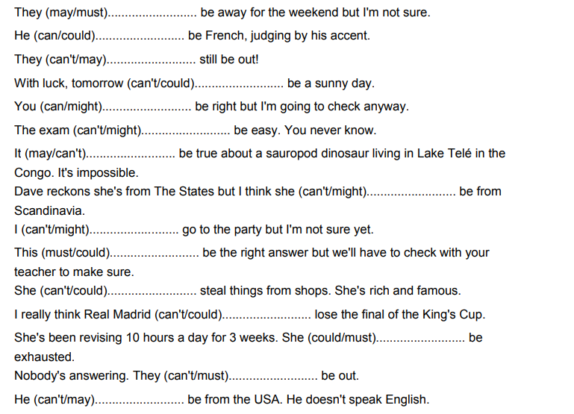
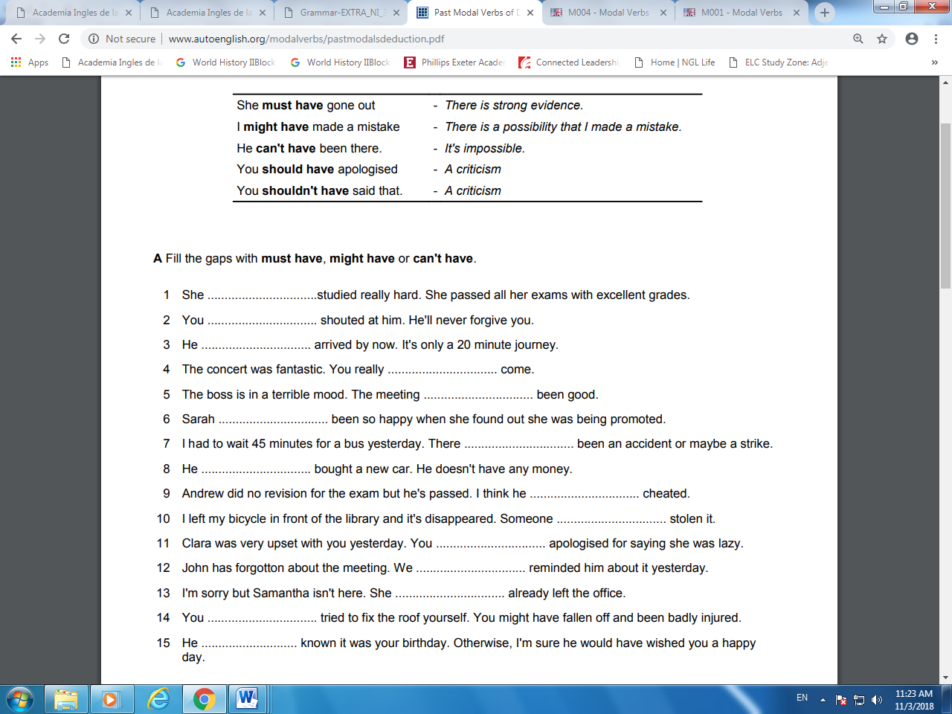

- Complete the story with the phrases below
EASTER ISLAND
Easter Island, 3,000 km off the coast of Chile in the Pacific Ocean is very far from land. Today, it is a small island with few people or trees , but at one time a lot of people lived there. Scientists believe that the original inhabitants (1)_____________________________________ by accident. Around 100 people (2)_______________________________ on the western coast of the island. But then the number of inhabitants increased too quickly. Scientists agree that the inhabitants (3)__________________ _________________ on the island and finally all died. The Easter Island statues are famous, but nobody knows why they are there or why there are so many. The statues (4)_____________________________, or Easter Island (5)__________________________ of a much bigger island. The statues are very large and heavy, so they (6)________________________ to move. Scientists still do not know how the inhabitants (7)__________________________ .

may have landed
might have done this
must have used up all the food
can’t have been easy
may have discovered the island
should have done this
could have been part
might have been gods
must not have landed

