Life In Extreme Environments
Planet Earth- it’s pretty cozy for life, right? At first glance maybe so, but what about the scorching hot geothermal pools and deep sea hydrothermal vents, or the freezing cold polar regions? Earth presents many challenges to life, but it seems that life always finds a way, even in the most surprising places. This article is going to explore life found in extreme environments on Earth, and how they’ve adapted to these harsh conditions.

YOU’RE GONNA NEED A BETTER COAT
Organisms that live in extreme environments are broadly called extremophiles. Microorganisms that can grow and reproduce at cold temperatures, typically below 15ºC and as low as -20ºC, are called psychrophilic. These environments are ubiquitous on Earth since a large proportion of the surface of the Earth experiences temperatures between this ranges. Examples include Polar Regions, mountains and deep ocean waters. Although many mammals live in these environments, mammals have a central heating system that other organisms don’t. This means that they can maintain a fairly constant internal temperature despite changing external temperatures. What about those that can’t do that, such as these microbes?
Psychrophilic organisms are presented with many challenges. One of the main problems is that biological reactions slow down because molecules have less kinetic energy, and enzymes begin to become more rigid. Membranes also begin to lose function because they become much less flexible. Microbes have developed clever ways to overcome this, for example by changing the composition of their membranes by adding more branched fatty acids so that they’re more flexible at colder temperatures. They also have cold adapted enzymes which possess fewer bonds that hold them together, again making them more flexible so they’re functional at low temperatures.
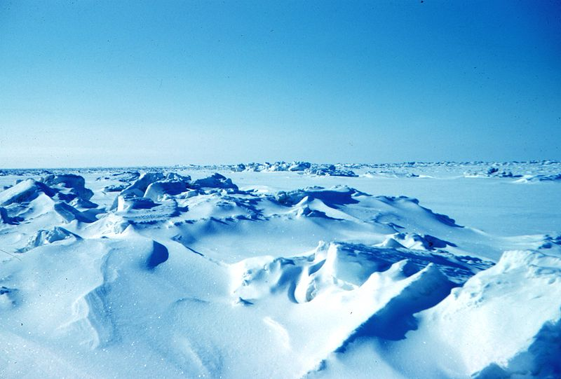

HERE’S TO BETTER ICE CREAM
Why do we care about these microbes? Well, they’ve actually got lots of cool applications, excuse the pun. They’re surprisingly common in the food industry; cold adapted bacteria are often used in the fermentation of beer and wine. Some proteins from these psychrophilic also have potential uses in the manufacture of ice cream because they can reduce the size of ice crystals and thus improve the texture. Certain types of psychrophilic bacteria are also added to the water used to make artificial snow, because they can raise the temperature for snow formation by as much as 20ºC!


I’M LITERALLY FREEZING!
Other organisms that have interested researchers in recent years are animals that can tolerate large amounts of their bodies being frozen and then thawed. The Antarctic nematode P. davidi can survive over 80% of its water freezing, and it does this by producing high concentrations of a cryoprotectant sugar called trehalose. It can also avoid freezing by dehydration, and is one of the few organisms known that can even survive anhydrobiosis, which is a total loss of water.
There are a few bigger organisms such as insects, fish and reptiles that can also tolerate freezing to an extent, but none are quite like the wood frog. These frogs can tolerate an incredible two thirds of their water being frozen. Not only that, but during these freezing periods their hearts stop beating for up to weeks at a time. Like the nematode, wood frogs also produce high concentrations of cryoprotectant molecules such as glucose and urea, which reduce the freezing point of the tissue. Scientists have turned to these incredible organisms in the hope of finding a way to be able to freeze organs that are required for transplantation so that they can be transported long distances to those in need, without damaging the tissue.
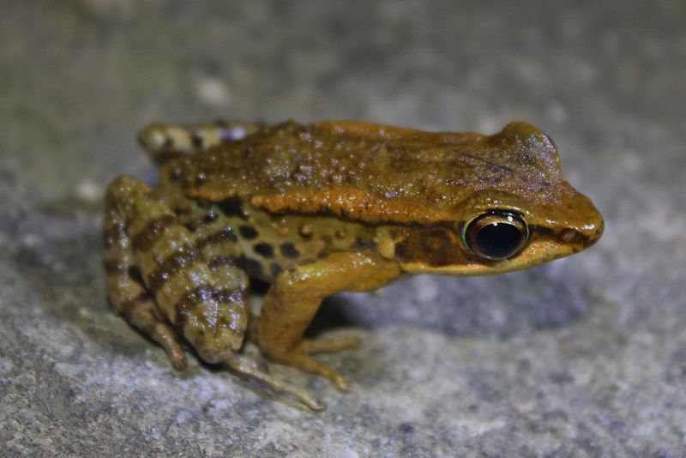
Wood frog. Wikimedia commons.

IT’S GETTING HOT IN HERE
Most organisms on Earth live between 0-48ºC; few plants or animals can survive for extended periods above the top end of this range. Sure, us mammals might be able to fan ourselves and sweat a bit, but what about organisms that manage to live at temperatures of, say, 100ºC?
At extreme heat, basically the opposite happens to what occurs at extreme cold. The bonds holding together proteins that make up the organism start to break and the protein will lose its shape, rendering it non-functional. This is called denaturation; that's why egg whites go from transparent to opaque when cooked. This usually happens at temperatures of above 45ºC. If the temperature isn't too high, the denaturation process can be reversible.

DEEP SEA CHIMNEYS
Let's start with deep sea hydrothermal vents. Hydrothermal vents are areas where tectonic plate movement under the sea floor causes water to spurt out at extreme temperatures. The water shoots out at about 300ºC, but the cool temperature of the surrounding sea water rapidly drops the temperature. Most animals chilling around here live at about 30ºC, such as some crabs and shrimp. But there are a few organisms that top the extreme chart. One such example is the Pompeii worm, which is the world's most heat tolerant animal. This worm builds tubes to live in, where the hot water flushes through and mixes with the cold water. Temperatures at the base of the tube are an average of 81ºC. These vents are also teaming with microbial life, including numerous bacterial and archaeal species. Those living around these vents have been isolated from temperatures of up to 115ºC! These organisms are called thermophiles.
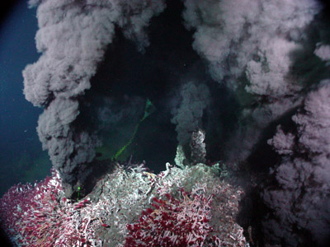
A type of deep sea hydrothermal vent called a black smoker. Wikimedia commons.

BACTERIAL HOT TUBS
Another example of scorching environments which are surprisingly rich in microbial life are hot springs. The most famous bacterial species isolated from springs in Yellowstone National Park is Thermophilus aquaticus which can live in boiling hot environments. Scientists isolated a heat tolerant protein called taq polymerase from this species which is used in the polymerase chain reaction, a process that allows scientists to produce huge numbers of copies of DNA in a short period of time. This is used in things like diagnostic tests and forensics.
So how do these heat crazed microbes do it? The internal temperature of a microbe is the same as that of the external environment- since enzymes start to denature around 45ºC, how do they overcome this? The bacteria produce heat tolerant enzymes that have an increased number of bonds that hold the protein together, which makes them more rigid and less susceptible to denaturation. The fat (lipid) composition of the membranes of these extremophiles is also different to those living in "normal" temperatures- they contain more saturated fatty acids which form stronger bonds, therefore again making them more rigid.
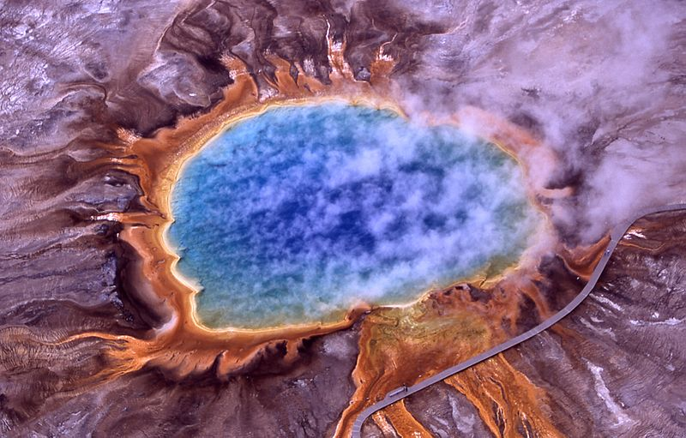
Grand prismatic spring, Yellowstone National Park. Wikimedia commons.

I AIN’T SCARED OF NO RADIATION
Ionizing (high energy) radiation can be pretty bad news; it is capable of breaking the DNA of organisms, sometimes even both strands at a time. Examples of ionizing radiation include X-rays and alpha particles. Although organisms possess DNA repair machinery, if the damage is bad enough they won’t be able to fix it. But there are a couple of extreme organisms that have an amazing capacity to withstand crazy amounts of radiation.
Our first organism is another microbe- Deinococcus radiodurans. This hard core bacterium was discovered in the 1950’s whilst a scientist was experimenting with using gamma radiation to sterilize meat, but this little guy always managed to survive. D. radiodurans can tolerate 1,500 kilorads without experiencing mutation. A rad is a unit of absorbed ionizing radiation dose. That’s about 3,000 times what humans can withstand. The key to its ability to withstand radiation lies within its DNA which is tightly packed into a ring, so that fragments severed by radiation can be kept close and eventually put back together by repair mechanisms.
There’s another bizarre organism which can withstand high levels of radiation- the Bdelloid rotifer. They’re tiny invertebrates that can be found in freshwater habitats that reproduce asexually. Weirdly, the DNA of these animals gets blasted apart by high levels of radiation just like any other organism, but it is capable of stitching it back together incredibly well with sophisticated repair mechanisms. This organism happily lives in radiation free zones, so why has it evolved efficient repair mechanisms? Scientists believe that dehydration and radiation can cause similar problems, including the creation of reactive oxygen species which damage DNA. Since the Bdelloid rotifer can also withstand dehydration, scientists believe radiation resistance is just a useful side-effect.
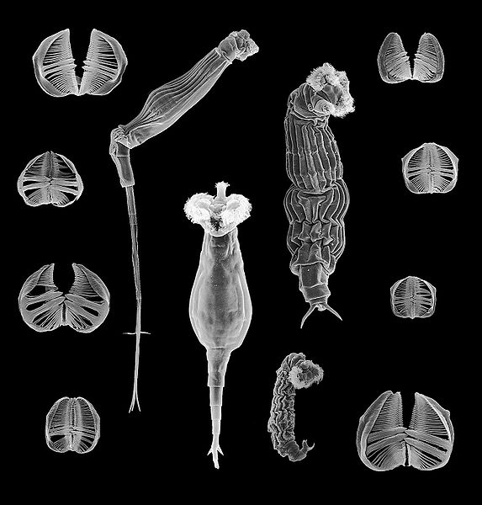
Morphological variation of Bdelloid rotifers and their different types of jaw. Wikimedia commons.

THE TOUGHEST OF THE TOUGH
There’s a group of extremophilic organisms that make all of these other organisms seem like pansies in comparison, and they are just the cutest little micro-animals you’ll ever see. I am of course talking about tardigrades, or water bears. You’ll find them the most extreme environments on Earth- deserts, glaciers, hot springs, swamps, the tops of the highest mountains and the deepest parts of the ocean. In sum- they’re pretty badass. They can lose up to 99% of the water in their bodies and enter a complete ametabolic state, which is called cryptobiosis. But when put back into water they re-animate, and they can happily do this after being desiccated for up to 10 years. The record is 150 years, but unfortunately this little trooper died pretty quickly afterward, and some argue that it never fully re-animated.
Tardigrades can also cope with extreme temperatures and can survive at a range of close to zero to 150ºC. They’re also extremely resistant to both radiation and pressure and were sent into space in 2007 as the first animals tested for survival in open-space conditions. They were subjected to the near vacuum of space and all of that lovely solar and cosmic radiation, but these awesome teddy bears came back to Earth surprisingly unscathed. Well, 68% of them did, but that’s still a pretty incredible number to survive. All hail the tardigrade.
So what do scientists believe these super-organisms possess that makes them so hardy? One substance is something we have already touched upon; trehalose. This sugar replaces lost water molecules connected to membranes and macromolecules within cells, and so helps to protect against the damage caused by desiccation.
