Adjectives and the comparative

Use -er for one-syllable words

For one-syllable words we add -er to the adjective to make it a comparative. The following are all one syllable adjectives:
Small becomes smaller
Cheap becomes cheaper
Quick becomes quicker

Use more / less for two+ syllable words

Adjectives with two or more syllables take more / less:
Beautiful becomes more beautiful
Sensitive becomes more sensitive
Dangerous becomes more dangerous
Note - If the adjective ends in a consonant-vowel-consonant combination (CVC), double the final consonant before adding –er:
Big becomes bigger
Hot becomes hotter
Wet becomes wetter

Use -ier for adjectives ending with y
For most adjectives that end with a y we change the y to i and add er:
Dirty becomes dirtier
Smelly becomes smellier
Ugly becomes uglier

Some adjectives take both forms
Some two-syllable adjectives can take either -er or more:
Simple becomes simpler or more simple
Narrow becomes narrower or more narrow
Quiet becomes quieter or more quiet

Irregular forms
Some adjectives don't follow any of the above rules. Here are some of the most common irregular forms:
good becomes better
bad becomes worse
far becomes farther
Compare using the word in parenthesis
Bob is (YOUNG) than Homer.
Homer is (OLD) than Alice.
Alice is (SLIM) than Bob.
Bob is (SHORT) than Homer.
Homer is (FAT) than Bob.
Alice is (SHORT) than Homer.
Homer is (UGLY) than Alice.
Homer is (SLOW) than Bob.
Bob is (TIDY) than Homer.
Alice is (BEAUTIFUL) than Bob.
Alice has got (LONG) hair than Bob.
Homer can play the guitar (GOOD) than Alice.
Alice can run (FAST) than Homer.
Alice draws (BAD) than Bob.
Bob is (INTELLIGENT) than Homer.
Homer is a (INTERESTING) person than Bob.

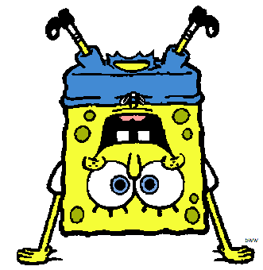
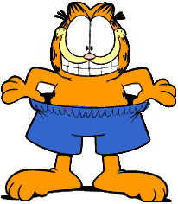
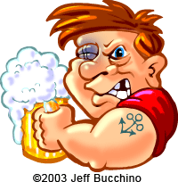
Harry Garfield Sponge Bob
32 years old 10 years old 6 years old
75 kilos 60 kilos 3 kilos
1.90 mt 0.57 mt 0.20 mt
Compare the following people and cartoons
Garfield Sponge Bob. (YOUNG-OLD)
Sponge Bob Harry. (FAT-SLIM)
Harry Sponge Bob. (SHORT-TALL)
Garfield Harry. (SHORT-TALL)
Garfield Harry. (FUNNY-BORING)
Sponge Bob's eyes Harry's. (SMALL-BIG)
Harry Garfield. (STRONG-WEAK)
Garfield Harry. (BEAUTIFUL-HORRIBLE)
Bob Sponge at sports Garfield. (GOOD-BAD)

Using the following list of adjectives write one sentence using comparatives

Common Adjectives

- big
- large
- short
- fast
- hot
- good
- old
- pretty
- fat
- happy
- full
- dark
- funny
- interesting
- cheap
- high
- deep
- healthy
- rich
- soft
- easy
- clean
- safe
- same
- early
- strong
- top
- beautiful
- handsome
- hungry
- thirsty
- tired
- busy
- free
- great
- friendly
- favorite
- little
- small
- tall/long
- slow
- cold
- bad
- new/young
- ugly
- thin/skinny
- sad
- empty
- light
- serious
- boring
- expensive
- low
- shallow
- sick/ill
- poor
- hard
- difficult
- dirty
- dangerous
- different
- late
- weak

