Inventions and Discoveries.
Did you know that some of the most famous inventions and discoveries were made by accident? Everybody knows Penicillin but what you probably don’t know is that it was discovered by Scottish scientist Alexander Fleming. He was a little messy and disorganized and a dish containing bacteria was left in his laboratory. When he came back from holiday, he noticed mould had grown in the dish but no bacteria were growing in the areas covered by mould . Then, he proved bacteria that caused human infections could be killed by mould. Using this discovery Howard Florey and Ernst Boris Chain developed penicillin to be used as medicine.
Have you ever used sticky notes? A very weak type of glue was invented by Spencer Silver in 1968. One day his friend Arthur Fry was singing in church and his bookmarks kept falling out of his song book. He remembered Silver’s glue, so the glue was used on his bookmarks. Later this idea was developed into sticky notes.
Every home needs a microwave oven. In 1946 Percy Spencer was working on a radar research when he made an interesting discovery. A magnetron was being tested and he noticed a chocolate bar in his pocket had melted. Later some experiments were done and Spencer found out the microwaves can cook food faster than conventional ovens because the food is cooked from inside. Then, he created the microwave oven.
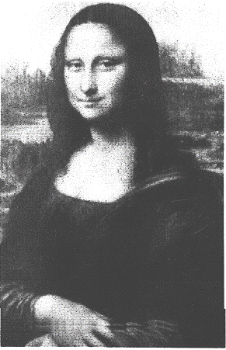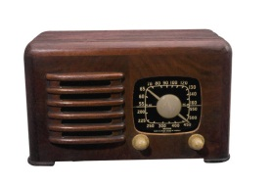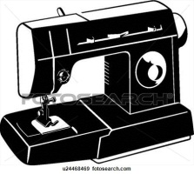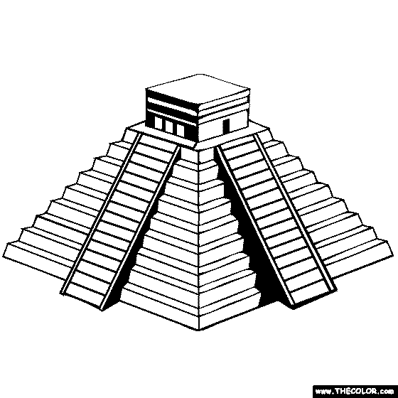

Practice.
EXERCISE 1. Complete the sentences using PASSIVE VOICE. (Present or Past).
- “One Hundred Years of Solitude” ______________________ by Gabriel García Marquez. ……………………………………………………………………………………………………………………………..(write)
- The pyramids ___________________ by the Egyptians……………………………………….. (build)
- The Theory of Relativity _________________ by Albert Einstein………………….. (formulate)
- Spanish ________________ in Argentina, Venezuela, and Honduras…………………. ( speak)
- San Fernando de Omoa fortress ______________ by tourists every year………………. (visit)
- “Don’t you worry child” __________________ by Swedish House Mafia.……………....(sing)
- The radio ________________ by Marconi…………………………………………………………. ( invent)

EXERCISE 2. Now create sentences using the words given.
Eg; sugar / use / sweeten / coffee
Sugar is used to sweeten coffee .
IN PRESENT.
- Race cars / drive / expert drivers
_________________________________________________________________________.
- Cupcakes / make / flour and eggs
_________________________________________________________________________.
- Smart phones/ buy / everybody
_________________________________________________________________________.

IN PAST

- America / discover / in 1492.
_________________________________________________________________________.
- My new bed/ get / La Curacao.
_________________________________________________________________________.
- John Lennon / killed / Mark David Chapman
_________________________________________________________________________.

EXERCISE 3. Now change the sentences from ACTIVE to PASSIVE.
- Romans invented concrete.
_________________________________________________________________________
- Leonardo Da Vinci painted “The Gioconda”.
_________________________________________________________________________
- So many tourists visit The Louvre museum in Paris.
_________________________________________________________________________
- Pierre and Marie Curie discovered radiation.
_________________________________________________________________________
- We eat nacatamales in Honduras.
_________________________________________________________________________

