IMPERATIVES NAME:____________________
DATE:_____________________
- Make an imperative sentence for each of the following situations.
1. You are a teacher. Give some instructions to start a class.
_________________________________________________________________________________
2. You are a father or a mother. Your son is going to practice karate for the first time. You are worried.
You say…
_________________________________________________________________________________
3. You are a doctor. You have a patient with cough and fever. Give him some basic recommendations.
_________________________________________________________________________________
4. You have a little brother. He’s eating dirt from the flowerpot. What do you say?
_________________________________________________________________________________
5. You had an accident. You are in bed and can’t move. You need some help…
_________________________________________________________________________________
6. You have a sister. She's going on vacation to the beach. Give some advice to her…
_________________________________________________________________________________
7. It is cold and windy outside. You are going to go out. Your mother says…
_________________________________________________________________________________
8. Your friends are going to go shopping. You want something. You say…
_________________________________________________________________________________
9. You have a little sister. You are going out to school, but she is taking too long to get ready. It’s 6:35!
You say…
_________________________________________________________________________________
10. Your cousin is at home using your computer, but you need it now to do some homework. You say…
_________________________________________________________________________________
- Match the sentences in order to have an imperative sentence.
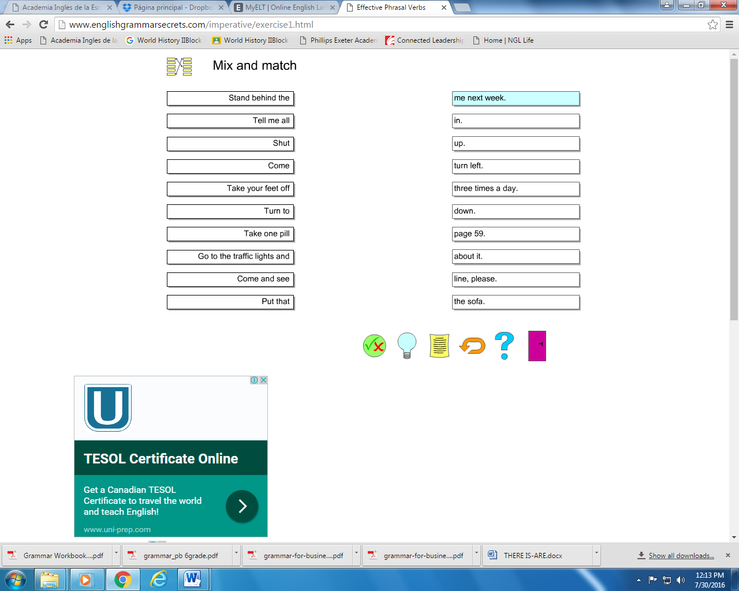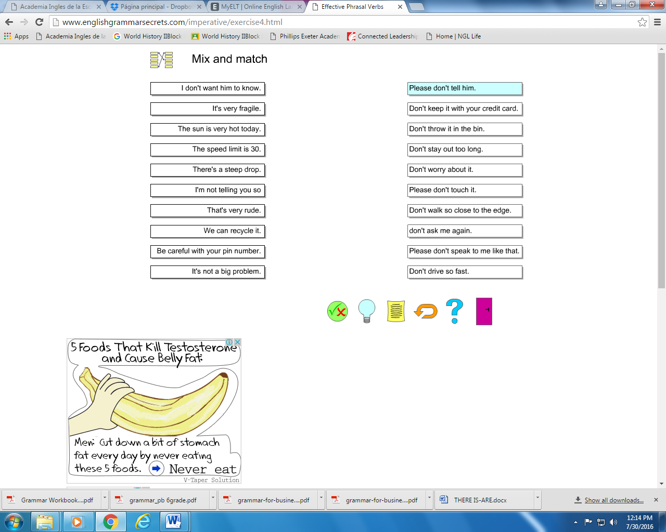
A
B
C
D
E
F
G
H
I
J

11.___
12.___
13.___
14.___
15.___
16.___
17.___
18.___
19.___
20.___

1.___
2.___
3.___
4.___
5.___
6.___
7.___
8.___
9.___
10.___

A
B
C
D
E
F
G
H
I
J

