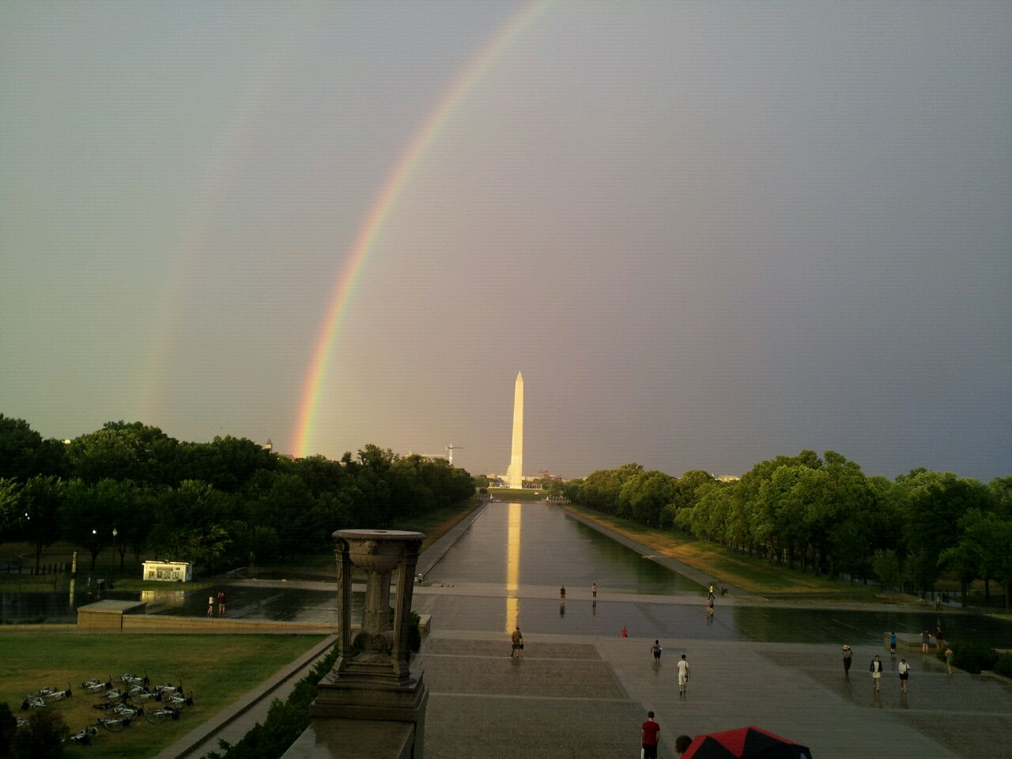
I took this picture on my last trip to the United States 6 years ago when I just arrived in Washington DC with a friend. This was my first time in Washington. We flew there from Austin to Washington by airplane. We stayed in a huge hotel called Gaylord National Resort and Convention Center on the Potomac River which is over thirty minutes away from D.C. This hotel is the biggest I stayed in. Right after we checked in, we took a bus tour through the city. We visited different monuments and the bus driver stopped at every landmark so that the tourists could take a walk and take pictures of them. We walked to the Lincoln Memorial when suddenly it started to rain. The weather was fantastic but we got wet that afternoon. Although it was raining, I was so amazed to see Abraham Lincoln monument that I did not notice what the other people were doing. When I turned my head, I saw everyone taking pictures of this beautiful double rainbow over The Washington Monument. There is no filter or special lens used to take the picture. In fact I took this picture with my cellphone and I really like it because the view was fantastic. I like to take lots of pictures because it is fun. During this trip I took more than 4,000 pictures, ate at different restaurants, and drank so much wine.
EXERCISE 1.
Answer the following questions.
- When and where did she take the photograph?
- What happened when she took the photograph?
- Who are the people in the picture?
- Is there any technical photographic information about it?
- Why does she like it?

EXERCISE 2.
Find six VERBS IN SIMPLE PAST in the text.
- __________________________________ 4. _________________________________
- __________________________________ 5. _________________________________
- __________________________________ 6. _________________________________

EXERCISE 3
Complete the sentences that are POSITIVE.
- She _____________________________in Washington City before.
- She _____________________________in a hotel.
- She _____________________________there by plane.
- She _____________________________in different restaurants.
Complete the sentences that are NEGATIVE.
- She ____________________________a bike tour.
- The weather ____________________________sunny.
- She ____________________________ New York.
- She ____________________________Tatascan there.

EXERCISE 4.
Circle all the sentences in SIMPLE PAST in the text.
EXERCISE 5.
Now Use the verbs to create sentences about your last vacation that are true for you. Use the SIMPLE PAST.
- Travel (+)__________________________________________________________________
- Eat(+)_____________________________________________________________________
- Drink(+) __________________________________________________________________
- Visit (-)____________________________________________________________________
- Play (-)____________________________________________________________________
- See(-)_____________________________________________________________________
EXERCISE 7.
Now say things YOU DID YESTERDAY these days.
- __________________________________________________________________________
- __________________________________________________________________________

