Human body: Body, Head, Eye, Hand, Foot; Internal Organs
Rating: 3.9/5 (183 votes cast)

Parts of the body – Body parts - Picture Dictionary
Body Part– Flashcard
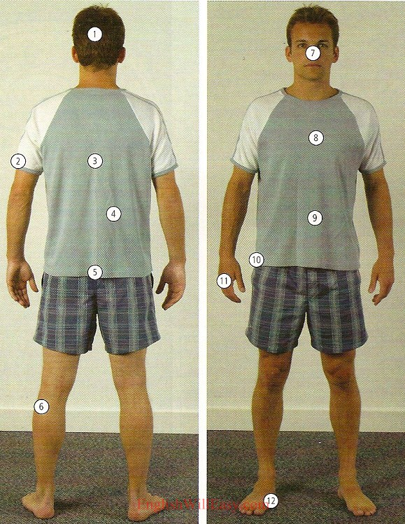
1. head 2. arm 3. back 4. waist 5. buttocks/ backside 6. leg 7. face 8. chest
9. stomach 10. hip 11. hand 12. foot
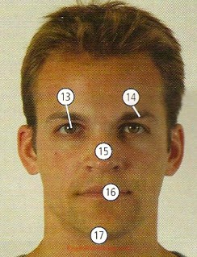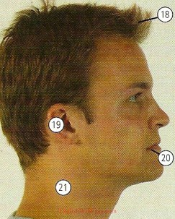
13. eye 14. eyebrow 15. nose 16. mouth 17. chin
18. hair 19. ear 20. lips 21. neck
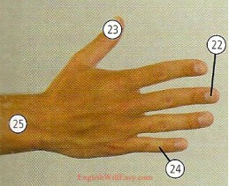
22. nail 23. thumb 24. finger 25. wrist
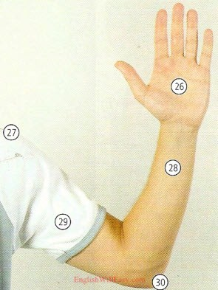
26. palm 27. shoulder 28. forearm 29. upper arm 30. elbow
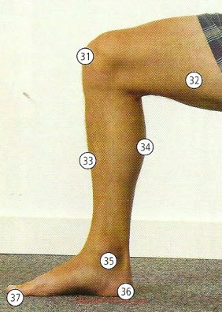
31. knee 32. thigh 33. shin 34. calf 35. ankle 36. heel 37. toe
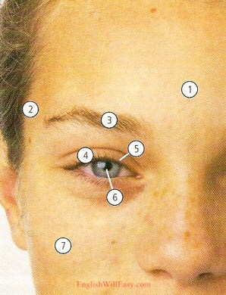
1. forehead 2. temple 3. eyebrow 4. eyelid 5. eyelash
6. pupil 7. cheek
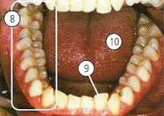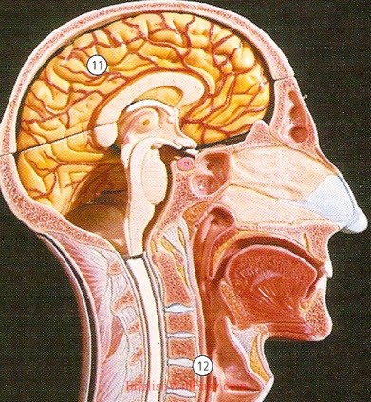
8. teeth 9. tooth 10. tongue 11. brain 12. throat
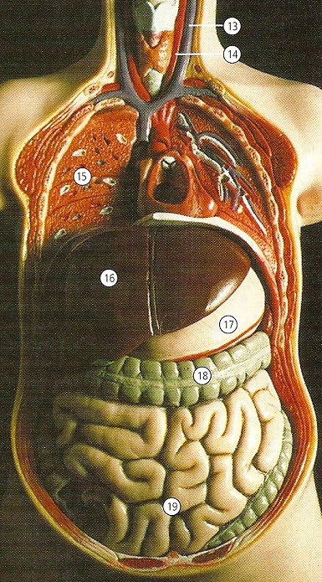
13. vein 14. artery 15. lung 16. liver 17. stomach 18. large intestine
19. small intstine
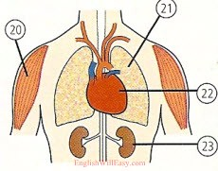
20. muscle 21. lung 22. heart 23. kidney
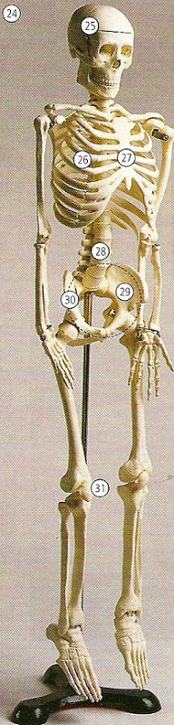
24. skeleton 25. skull 26. ribs 27. breastbone/ sternum
28. spine/ backbone 29. hip-bone 30. pelvis
31. kneecap

Human body: Body, Head, Eye, Hand, Foot; Internal Organs

BODY
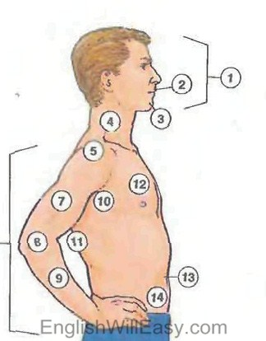
1. face; 2. mouth; 3. chin; 4. neck; 5. shoulder; 6. arm;
7. upper arm; 8. elbow; 9. forearm; 10. armpit; 11. back;
12. chest; 13. waist; 14. abdomen;
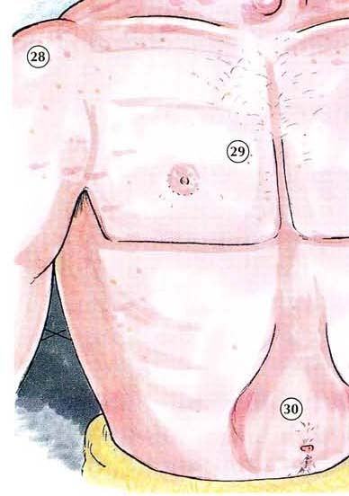
28. shoulder 29. chest 30. abdomen
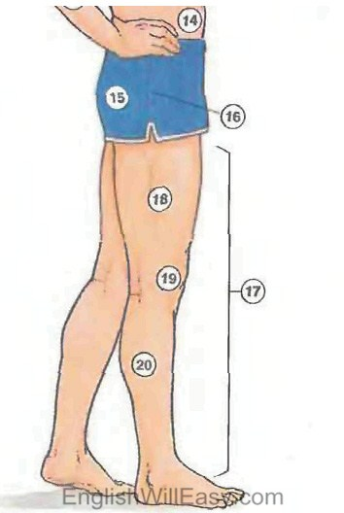
15. buttocks; 16. hip; 17. leg;
18. thigh; 19. knee; 20. calf;
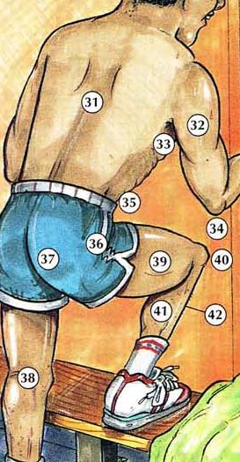
31. back; 32. arm; 33. armpit 34. elbow; 35. waist
36. hip; 37. bullocks; 38. leg 39. thigh; 40. knee;
41. calf 42. shin

Body Image
HUMAN BODY MAN ANTERIOR VIEW
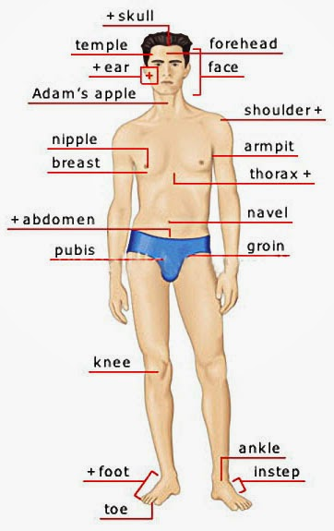

skull, temple, ear, forehead, face, Adam’s apple , shoulder, nipple, breast, armpit, thorax, navel, abdomen, pubis, groin, knee, foot, toe, ankle, instep

