HOMEWORK: November 3rd.

- Exam unit 6.
- Project #2 “A Post Card from Outer Space” Consider:
- Research about a place from this unit or a place scientists have discovered to learn more about it.
- Imagine you took a week long journey to this place. Write a post card message about your trip. Include information on traveling and from your destination.
- Create a Power Point Presentation of a Postcard and include the message and illustration of the place.
- Give a Speech to the class presenting you postcard.

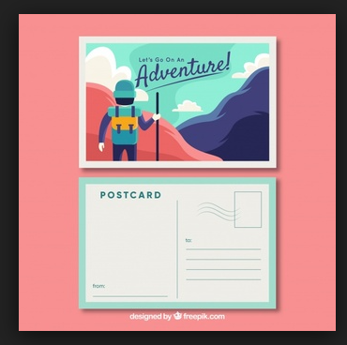
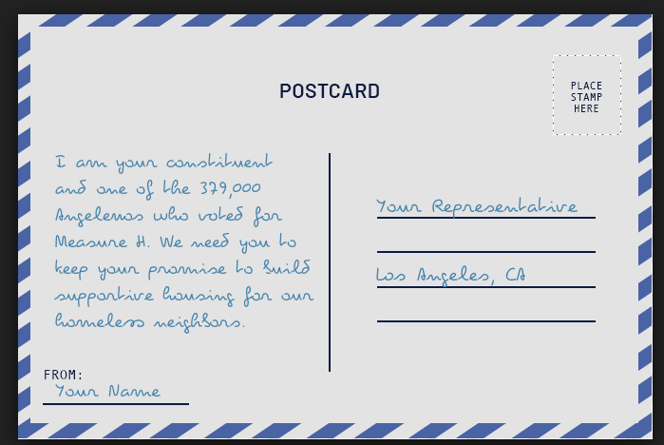
Post card example

