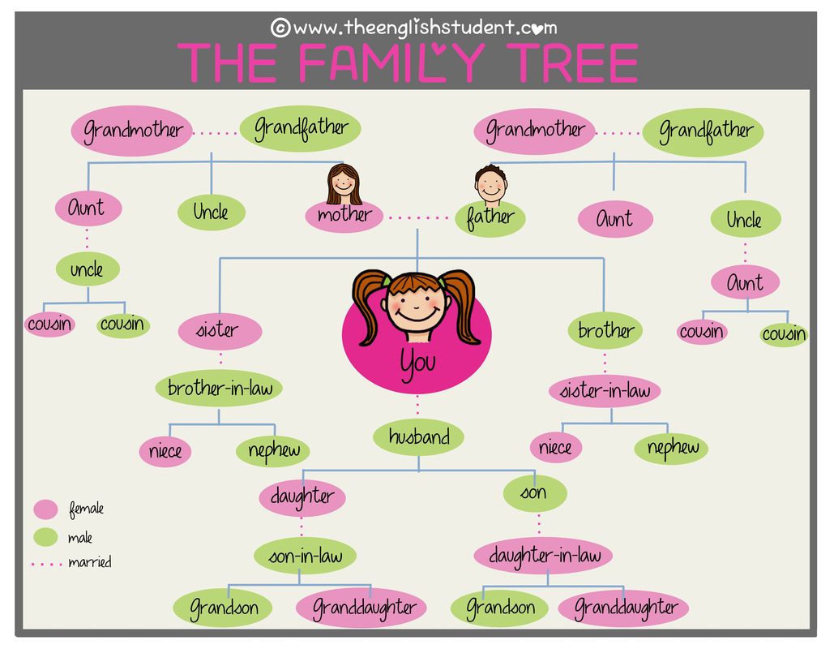
Family-Related Word | Example Sentence
aunt | My aunt tells me funny stories about my mother's youth.
brother | My brother is very competitive.
cousin | My cousin left for college last year.
daughter | She has one daughter and one son.
father | My father spent a lot of time on the road for work.
grandchild | That 90-year-old woman has 20 grandchildren!
granddaughter / son | His granddaughter gave him a birthday card with a bunny.
grandfather / mother | Do you remember your grandmothers and grandfathers?
great-grandchildren | She has four great-grandchildren and is very happy to be alive and to have met them all!
husband | She sometimes argues with her husband, but that's normal in every marriage.
ex-husband | She had to divorce her ex-husband because he cheated on her.
in-laws | Many people don't get along with their in-laws. Others are happy to have a new family!
son-in-law, daughter-in-law, bother-in-law, sister-in-law,  mother-in-law, father-in-law | Her daughter-in-law told her to mind her own business.
mother | Mother knows best, or at least that's what my mother always said.
niece | His niece works in a shop in Seattle selling eyewear.
nephew | I have a nephew who lives in town. It's nice to have lunch every once in a while.
Parents (mother and father) | All of us have two biological parents. Some people grow up with adopted parents.
sister | His sister drove him crazy with her constant complaining about the parents.
son | Many people say that sons are harder to raise than daughters because they cause more trouble.
stepfather, stepmother | She gets along wither her stepfather, but she prefers to not call him "Dad."
stepdaughter, stepson  stepsister, stepbrother | If you marry him, you'll have two stepdaughters and one stepson.
twin | It's amazing how similar some twins are. They look, act, and talk alike.
uncle | My uncle lives in Texas. He's nothing like my father.
widow | She became a widow 20 years ago and never remarried.
widower | The widower is very sad because he's all alone now.
wife | My wife is the most amazing woman in the world because she puts up with me.
ex-wife | His ex-wife took all his money.
Half - brother , half- sister

Marital Relationships
- Divorced: Jennifer is divorced, but she's happy to be single again.
- Engaged: Helen is engaged to be married next June. She's making plans for the wedding.
- Married: I've been married for over 25 years. I consider myself lucky.
- Separated: In many countries, couples must be separated for more than a year in order to divorce.
- Single: He's a single man living in New York.
- Widowed: Hank became widowed last year. He hasn't been the same since.
- Get divorced (from): My husband and I got divorced three years ago. Now, we're best friends, but we know our marriage was a mistake.
- Get engaged (to): I got engaged to my wife after just two months of dating.
- Get married (to): We're planning on getting married in May.
- Marry someone: She married Tom 50 years ago today. Happy anniversary!
- Start / end a relationship with someone: I think we should end our relationship. We're not happy with each other.

