What if…?
Look at the picture. Read the question. Write the answer.

1.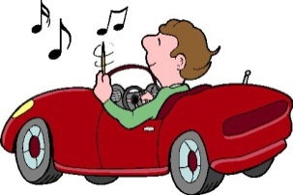 2. 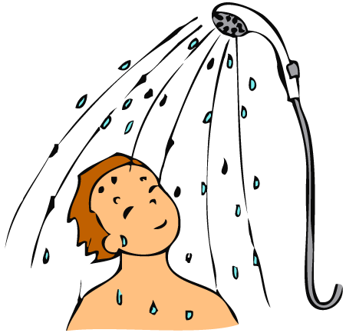 3. 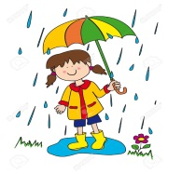 4. 

5. 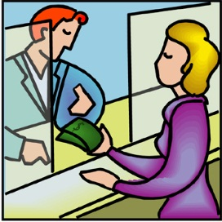 6. 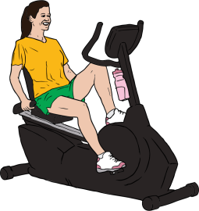 7. 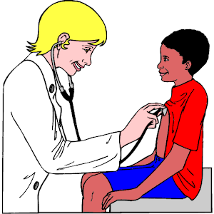 8. 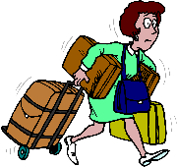
1. What do you do if you are stuck in traffic?
___________________________________________________________________________________
2. What do you do if it is hot?
___________________________________________________________________________________
3. What do you do if it rains?
___________________________________________________________________________________
4. What do you do if you feel hungry?
___________________________________________________________________________________
5. What do you do if you don’t have money?
___________________________________________________________________________________
6. What do you do if you feel fat?
___________________________________________________________________________________
7. Where do you go if you are sick?
___________________________________________________________________________________
8. What do you do if you have vacations?
___________________________________________________________________________________

