Questions: What are some good / bad things about living in a cave?

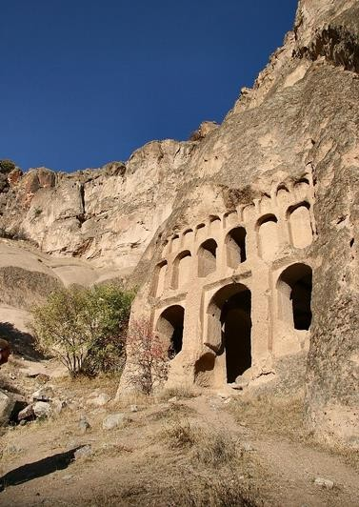

Read the article below and then answer the questions.

Cave Houses of Cappadocia
Located high in central Turkey, Cappadocia is a large region with hot, dry summers and cold, snowy winters. Many thousands of years ago, volcanic ash covered the land before humans lived there. After a long time, the ash turned into a kind of soft rock. Today, some of the natural rock formations reach forty meters into the air.
Much later, more than two thousand years ago, people began to cut homes into the soft rock, both above and below the ground. In fact, homes were not the only
things that people created there. They also made stables for animals, places to keep food and other supplies, and places to worship and pray. There are hundreds of these cave rooms that form entire towns, both high in the sky and deep below the ground (some as many as eight floors under the earth). Although many of the caves are now museums, some people still continue to live there as they did in the past.

Long ago, water and wind helped to create the wonders of Cappadocia, but now people are trying to save it from being destroyed by the same water and wind because they want Cappadocia to last for thousands of more years. In 1985, it became a World Heritage site, which means that it is one of the most special places in the world. Since 1983, several movies have been filmed there, including a 2014
film that won an award at that year’s Cannes Film Festival. If you decide to visit this popular tourist area, the main nearby town is Goreme, which offers tours, guides and even hot air balloons for you to fly quietly over the land and admire the amazing
view.

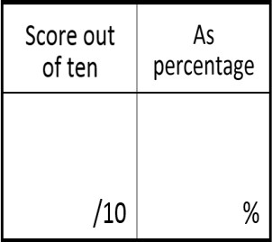
- READING COMPREHENSION
- Turkey is located in Cappadocia.
- TRUE
- FALSE
- It doesn’t say.
- Where did the soft rock come from?
- volcanoes
- people
- formations
- When did humans first make the caves?
- about two thousand years ago
- many thousands of years ago
- hundreds of years ago
- What did the people make who first lived there?
- museums to visit
- houses to live in
- houses, stables and areas to pray
- Where do some of the people in Cappadocia now live?
- in museums
- in caves
- in stables
- In Paragraph 2, what does ‘they’ refer to?
- towns
- museums
- people
- Why are people trying to save the cave houses of Cappadocia?
- They want a place to keep their animals.
- They don’t like water and wind.
- They want people in the future to see it.
- In Paragraph 3, what does ‘it’ refer to?
- Cappadocia
- the Cannes Film Festival
- Turkey
- How many movies about Cappadocia have won a Cannes Film Festival award?
- one
- several
- two
- Why do many people go to Goreme?
- to buy balloons
- to find guides
- to become tour guides

Grammar-in-Context
- Complete the paragraph by circling the correct words.

Located high in central Turkey, Cappadocia is a large region with hot, dry summers and cold, snowy winters. Many thousands of years ago, volcanic ash covered the land before humans (1) there. After a long time, the ash turned into a kind of soft rock. Today, some of the natural rock formations (2) forty meters into the air.

Much later, more (3) two thousand years ago, people began to cut homes into the soft rock, both above and below the ground. In fact, homes (4) not the only things that people created there. (5) also made stables for animals, places to keep
food and other supplies, and places to worship and pray. There (6) hundreds of these cave rooms that form entire towns, both high (7) the sky and deep below the ground (some as many as eight floors under the earth). Although many of the caves are now museums, some people still continue to (8) there as they did in the past.
Long ago, water and wind helped to create the wonders of Cappadocia, but now people are (9) to save it from being destroyed by the same water and wind because they want Cappadocia to last for thousands of more years. (10) 1985, it became a World Heritage site, which means that it is one of the most special places in the world. Since 1983, several movies have been filmed there, including a 2014 film that (11) an award at that year’s Cannes Film Festival. If you decide to visit this popular tourist area, the main nearby town is Goreme, which offers tours, guides and even hot air balloons for you to fly (12) over the land and admire the amazing view.

1.  - live  - lived  - living  - lives  2.  - reached  - reaching  - reaches  - reach  3.  - than  - thin  - then  - they  4.  - were  - are  - was  - did | 5.  - Them  - They’re  - They  - Their  6.  - have  - are  - is  - has  7.  - on  - in  - at  - to  8.  - lived  - lives  - living  - live | 9.  - try  - tries  - trying  - tried  10.  - At  - On  - To  - In  11.  - won  - win  - wins  - winning  12.  - quiet  - quieter  - quietly  - quietest


WRITING PRACTICE
- DESCRIPTIVE WRITING: “Write a short paragraph to describe how would you feel living in your dream house and would it be.” _
_

