ADJECTIVES – COMPARATIVE AND SUPERLATIVE FORM
NAME: ____________________________________________ DATE:_____________________________

- Choose the correct adjective to answer the question.

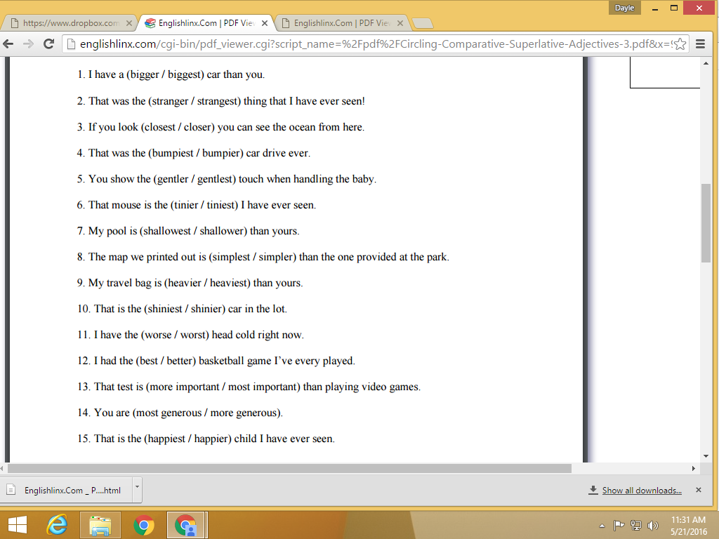

- Write the correct form of the adjective to complete. (Comparative or Superlative)
