Comparative form of Adjectives

When we compare things, people or even ideas we look at what makes them different from each other.
Comparative adjectives are used to show what quality one thing has more or less than the other. They normally come before any other adjectives.
!Tip - It's a good idea to learn opposites (antonyms) when learning adjectives.
For example:

Tall / Short
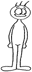
The man on the left is taller than the man on the right.
The man on the right is shorter than the man on the left.

!Note - Have you noticed that when we are comparing two things like this we put than between the adjective and the thing being compared.

Fast / Slow
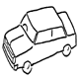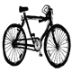
A car is faster than a bicycle.
A bicycle is slower than a car.
For example:

Big / Small
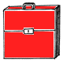
The red bag is bigger than the blue bag.
The blue bag is smaller than the red bag.

Forming the comparative
The way you form the comparative from an adjective depends – on the number of syllables and the spelling of the adjective.
Form | Rule | For example
Words of one syllable ending in 'e'. | Add -r to the end of the word. | wide - wider
For example:-
A motorway is wider than a road.

Words of one syllable, with one vowel and one consonant at the end. | Double the consonant and add -er to the end of the word. | big - bigger
For example:-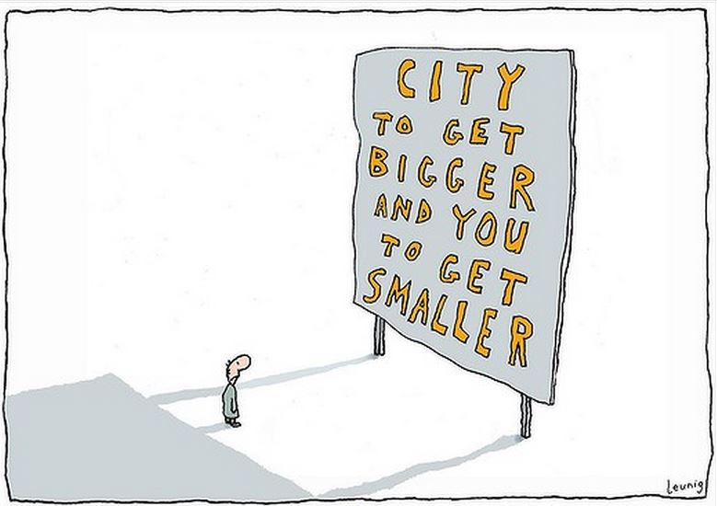
Words of one syllable, with more than one vowel or more than one consonant at the end. | Add - er to the end of the word. | high - higher
Mount Everest is higher than Mount Snowdon.
Words of two syllables, ending in 'y'. | Change 'y' to 'i', and add -er to the end of the word. | happy - happier
For example:-
Some people seem to be luckier than other people.
Words of two syllables or more, not ending in 'y'. | Place 'more' before the adjective. | beautiful - more beautiful
For example:-
Arguably Rome is more beautiful than Paris.

!Warning - For every rule, there is at least one exception and there are also irregular adjectives that you need to memorise as you come across them.
For example:-
- 'good' becomes 'better'
- 'bad' becomes 'worse'
- 'far' becomes 'farther' or 'further'

