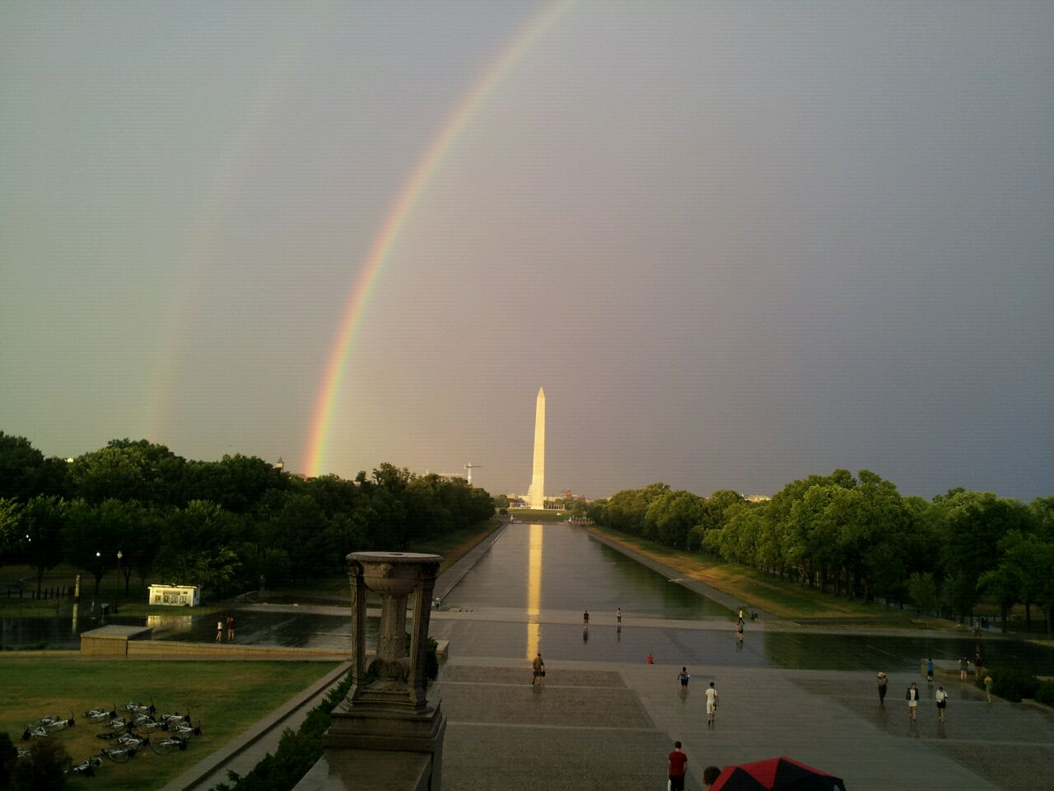
I took this picture on my last trip to the United States last year when I just arrived in Washington DC with a friend. I have traveled to the United States several times but this was my first time in Washington. We stayed in a huge hotel called Gaylord National Resort and Convention Center on the Potomac River which is over thirty minutes away from D.C. I have been to so many hotels but this one is the biggest I have stayed in. Right after we checked in, we took a bus tour through the city. I have flown on an airplane and I have also traveled by train. But I had never taken a bus tour before. We were visiting different monuments and the bus driver stopped at every landmark so that the tourists could take a walk and take pictures of them. We were walking to the Lincoln Memorial when suddenly it started to rain. The weather was fantastic but we got wet that afternoon. Although it was raining, I was so amazed to see Abraham Lincoln monument that I did not notice what the other people were doing. When I turned my head, I saw everyone taking pictures of this beautiful double rainbow over The Washington Monument. There is no filter or special lens used to take the picture. In fact I took this picture with my cellphone and I really like it because the view was fantastic. I have taken lots of pictures because I love taking pictures every time I travel. I have been thinking about going to New York City but I’d rather visit my sister in Miami because I haven’t seen her for a year, and I haven’t gone shopping either. But this year I will not be able to travel, I have been spending too much money, and everything is so expensive.
EXERCISE 1.
Answer the following questions.
- When and where did she take the photograph?
- What was she doing when she took the photograph?
- Who are the people or animals in the picture?
- Is there any technical photographic information about it?
- Why does she like it?

EXERCISE 2.
Find six VERBS IN PAST PARTICIPLE in the text.
- __________________________________ 4. _________________________________
- __________________________________ 5. _________________________________
- __________________________________ 6. _________________________________
EXERCISE 3
Complete the sentences that are POSITIVE.
- She _____________________________to the United States before.
- She _____________________________to so many hotels.
- She _____________________________by plane, and train.
Complete the sentences that are NEGATIVE.
- She ____________________________a bus tour before.
- She ____________________________at a big hotel before.
- She ____________________________to New York.

EXERCISE 4.
Circle all the sentences in PRESENT PERFECT in the text.
EXERCISE 5.
Now Use the verbs to create sentences that are true for you. Use the PRESENT PERFECT.
- Travel (+)__________________________________________________________________
- Eat(+)_____________________________________________________________________
- Drink(+) __________________________________________________________________
- Visit (-)____________________________________________________________________
- Play (-)____________________________________________________________________
- See(-)_____________________________________________________________________
EXERCISE 6.
Write the examples in SIMPLE PAST that you found in the text.
- ____________________ 3.________________________ 5.______________________
- ____________________ 4.________________________ 6. _____________________
EXERCISE 7.
Now write two QUESTIONS for your teacher about the picture and the text using the SIMPLE PAST.
- __________________________________________________________________________
- __________________________________________________________________________

