TEXTBOOK PAGE 29 EXERCISE 5C.
- They have had office success even though they are/he has made/he makes unusual movies.
Even though they are/he has made/he makes unusual movies, they have had office success.
- I enjoyed Romeo and Juliet but I didn’t understand all the dialog.
I didn’t understand all the dialog but I enjoyed the movie.
- In spite of praising Luhrmann’s earlier movies, the critics didn’t like Australia.
- I’ve seen all the movies. However, I haven’t seen any of the operas.
- His last movie was absolutely amazing, so I’m looking forward to seeing the next one.
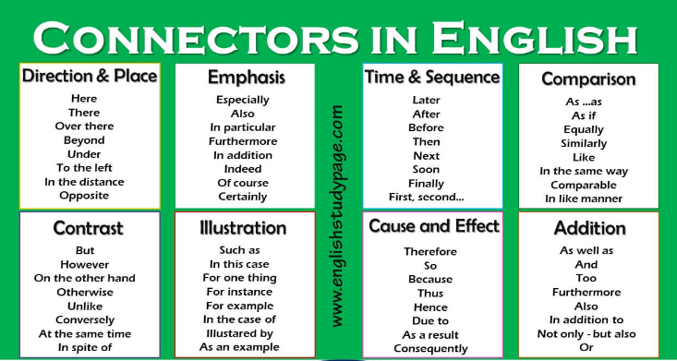

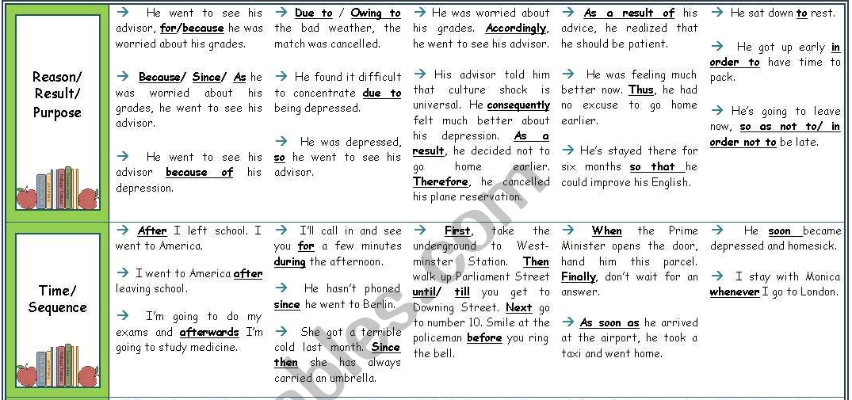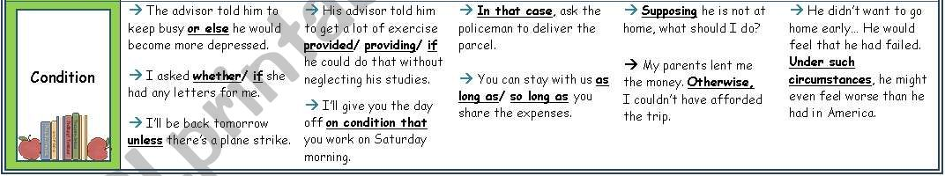
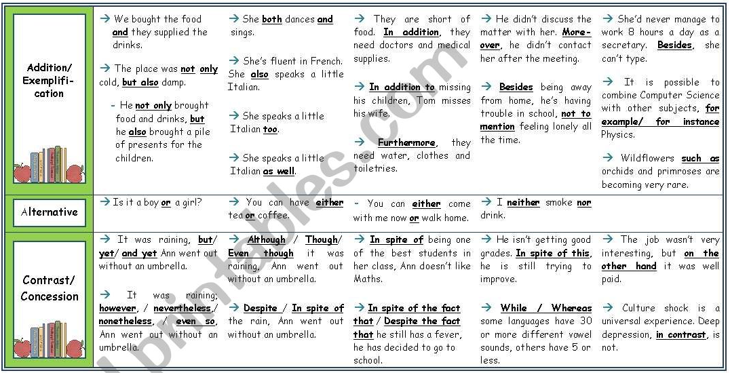

FOR EXTRA PRACTICE
https://es.liveworksheets.com/worksheets/en/English_as_a_Second_Language_(ESL)/Connectors/Connectors_xv168287ax
https://es.liveworksheets.com/worksheets/en/English_as_a_Second_Language_(ESL)/Connectors/Linking_words_ac351482ht

