English Vocabulary

The Human Body and Anatomy

Useful Vocabulary
The Human Body
ankle | arm | chest | foot | hand | knee  leg | neck | shoulder | back | bottom | calf | elbow | head  heel | thigh
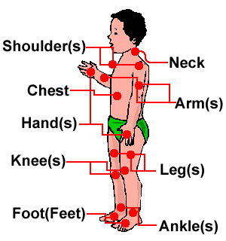 | 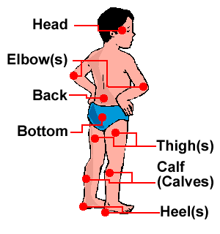
Close up on the foot | Close up on the hand
ankle | big toe | heel | little toe | toenail | index finger | knuckle | fingernails  little finger | middle finger  ring finger | thumb | wrist
Ads not by this site  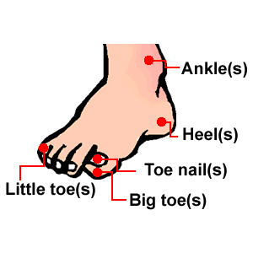 | Ads not by this site  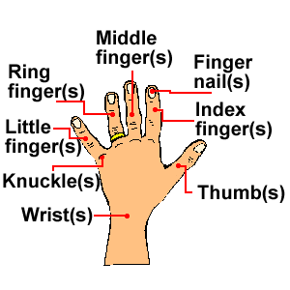

Build Up

Inside the Body - Simple Anatomy
bladder | The organ inside the body of a person, where urine is stored before it leaves the body. | 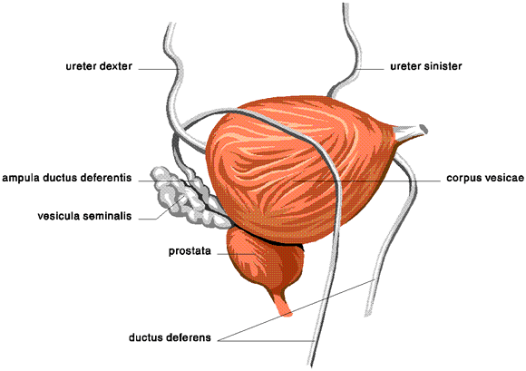
bone | The hard parts inside a human or animal that make up its frame. | Ads not by this site
brain | The organ inside the head that controls thought, memory, feelings and activity. | 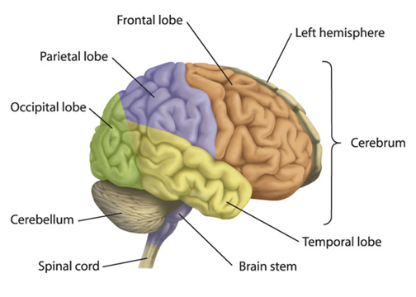
digestive system | The organs in your body that digest food. | 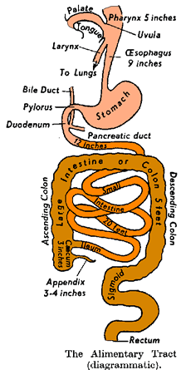
ear | The ear is made up of three different sections: the outer ear, the middle ear, and the inner ear. These parts all work together so you can hear and process sounds. | 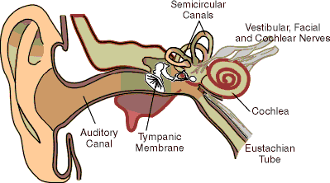Ads not by this site
eye | 'The eyes takes in information about the world around you - shapes, colours, movement, and more. Then they send the information to your brain. | 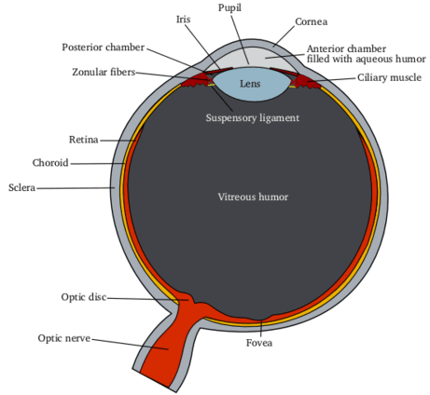
heart | The heart sends blood around the body. The blood provides oxygen and nutrients to the body. | 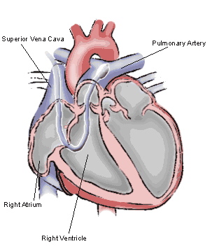
kidney | One of the main jobs of the kidneys is to filter the waste out of the blood. | 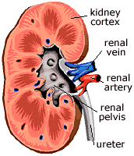Ads not by this site
liver | A large organ in the body which cleans the blood and produces bile (a bitter yellow liquid which helps to digest fat). | 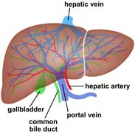
lungs | The lungs are one of the largest organs in the body, they work with the respiratory system to take in fresh air, and get rid of stale air. | 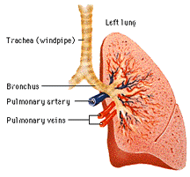
mouth | The opening in the face which consists of the lips and the space between them, or the space behind which contains the teeth and the tongue. | 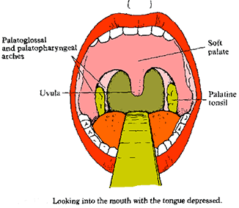Ads not by this site
skeleton | The frame of bones that support the body. | 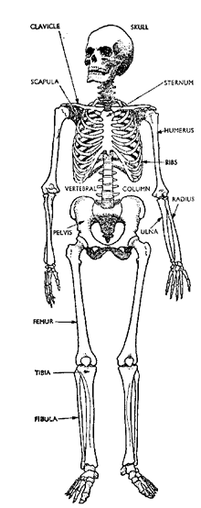
spine | The line of bones down the centre of the back that provides support for the body. | 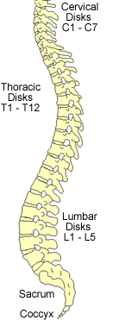
teeth | The hard white objects in the mouth, which are used for biting and chewing. | 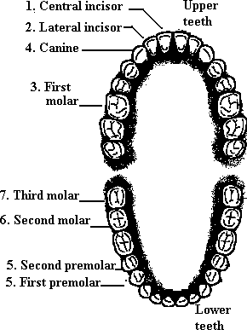Ads not by this site
tooth | (see above) | 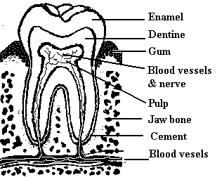
urinary tract | The parts of the body which produce and carry urine. | 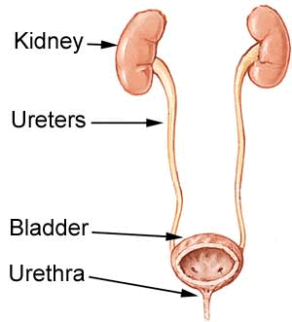

Naturally Speaking

Describing aches and pains
If your head hurts: | "I've got a headache." or "My head aches."
If your stomach hurts: | "I've got stomach ache." or "My stomach aches."
If your back hurts: | "I've got backache." or "My back aches."
If your neck hurts: | "I've got neckache." or ""My neck aches."
If other parts of your body hurt:

