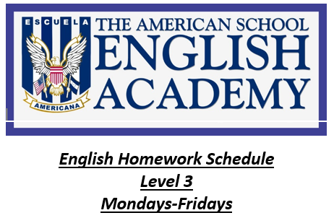
STUDENT’S NAME: _____________________________________________
TOTAL POINTS: ________/________ MR. RODRÍGUEZ
ENGLISH QUIZ UNIT 10 / BOOK LIFE
INTRUCTIONS: Read the instructions carefully. Just copy the responses on the sheet that was sent to you in the mail. Work clearly. Once you have finished according to the time provided (60 minutes), send your answer sheet to drodriguez@academiaingles.org in a PDF document.

GRAMMAR:
- COMPLETE THE SENTENCES ABOUT FAMOUS BRITISH EXPLORERS OF THE SIXTEENTH CENTURY. USE was / were. (6 points)
1.
2.
3.
4.
5.
6.

- COMPLETE THE TEXT WITH THE PAST FORM OF be. USE AFFIRMATIVE AND NEGATIVE FORMS.
(10 points)
1. 6.
2. 7.
3. 8.
4. 9.
5. 10.

- WRITE QUESTIONS. USE was OR were. (10 points)

It won’t be easy but it’ll be worth it!!!

- COMPLETE THE SENTENCES WITH THESE WORDS. (4 points)
Past ago time now
1.
2.
3.
4.
VOCABULARY:

- LOOK AT THE EXAMPLE. COMPLETE THE DATES. DICTATION (16 points)
1. 7 / 6 / 67 the sixth of July, 1967
2. 2 /18/ 79
3. 11 /1/ 90
4. 4 /3/ 50
6. 1 /22/ 29
7. 3 /12/ 19
8. 6 /25/ 99
9. 5 /11/ 87
10. 8 /30/ 31

- WHAT ARE THE ADJECTIVES? WRITE THE LETTERS IN THE CORRECT ORDER. COMPLETE THE SENTENCES. DICTATION (8 points)
2.
3.
4.
5.
6.
7.
8.

- MATCH THE WORDS AND EXPRESSIONS TO THE PICTURES. (6 points)
a.
b.
c.
d.
e.
f.
FUNCTIONS
- COMPLETE THE CONVERSATION WITH THESE WORDS. DICTATION. (10 points)
hello busy worry were late ok
sorry take about very

1. 6.
2. 7.
3. 8.
4. 9.
5. 10.
WRITING
- WRITE AN EMAIL: YOU MISSED A CLASS BECAUSE YOUR CAR BROKE DOWN. APOLOGIZE TO YOUR TEACHER. USE APPROPPRIATES EXPRESSIONS FOR STARTING AND ENDING EMAILS. (5 points)

FORMULA: POINTS EARNED X 100 = N
N ÷ 75 = TOTAL
EXAMPLE: 68 X 100 = 6,800 ÷ 75 = 90.66 = 91%

For God so loved the world, that he gave his only begotten Son…
JOHN 3:16

